System and Software Architecture Description (SSAD)

Arts and Crafts Website

Team No: 04

Abhishek Chauhan – Life Cycle Planner
Harsha Medikonda – Feasibility Analyst
Kelvin Zhu – IIV & V
Lauren Mermel – Operation Concept Engineer
Roopa Dharap – Project Manager
Sukriti Jain – System Architect

Version History
Date | Author | Version | Changes made | Rationale
10/14/12 | SJ | 1.0 | Added section 2.1.1 -2.1.3 | Initial version of SSAD
10/24/12 | SJ | 1.1 | Updated section 2.1.3 | After inputs from IIV and V changes made to System Context Diagram and added a new use case for a new requirement
10/30/12 | SJ | 1.2 | Updated section 2.1.1, 2.1.2 and 2.1.3 | Changes made in System Context Diagram, Artifacts and Information Diagrams and modified use cases as per comments received for Evaluation of Draft FC Package.
11/03/12 | SJ | 2.0 | Added section 3.1-3.3 | Changes are made as part of the DCP package
11/25/12 | SJ | 3.0 | Updated section 2.1.1, 2.1.3, 2.1.3. 3.1, 3.2, 3.3 | Changes made in System Context Diagram, Artifacts and Information Diagrams and modified use cases as per comments received for Evaluation of Development Core Package.  Changes made in the NDI/NCS Interoperability section due to change in the NDI.
11/30/12 | SJ | 3.1 | Updated section 2.1.1, 2.1.3, 2.1.3. | Changes made for the DCR ARB Session
12/02/12 | SJ | 3.2 | Updated section 2.1.1, 2.1.3, 2.1.3. | Changes made after evaluation of draft TRR package
12/08/12 | SJ | 3.3 | Updated section 2.1.1 | Changes made after comments received from DCR ARB
12/15/12 | SJ | 3.4 | Updated section 2.1.1, 2.1.2,2.1.3 | Changes made after evaluation of TRR package.

Table of Contents
System and Software Architecture Description (SSAD) i
Version History ii
Table of Contents iii
Table of Tables iv
Table of Figures v
1. Introduction 1
1.1 Purpose of the SSAD 1
1.2 Status of the SSAD 1
2. System Analysis 2
2.1 System Analysis Overview 2
3. NDI/NCS Interoperability Analysis 15
3.1 Introduction 15
3.2 System Structure 15
3.3 Evaluation Summary 15

Table of Tables
Table 1: Actors Summary 3
Table 2: Artifacts and Information Summary 3
Table 3: Process Description(View Product Listing) 4
Table 4: Typical Course of Action (View Product Listing) .5
Table 5: Process Description (View Product Details) 5
Table 6: Typical Course of Action (View Product Details) 5
Table 7: Process Description (Add Product) 6
Table 8: Typical Course of Action (Add Product)) 6
Table 9: Process Description (Remove Product) 6
Table 10: Typical Course of Action (Remove Product) 6
Table 11: Process Description (Purchase Product) 7
Table 12: Typical Course of Action (Purchase Product) 7
Table 13: Exceptional Course of Action (Purchase Product) 7
Table 14: Process Description (Write a Blog Comment) 8
Table 15: Typical Course of Action (Write a Blog Comment) 8
Table 16: Process Description (Sign up for Updates) 8
Table 17: Typical Course of Action (Sign up for updates) 8
Table 18: Alternate Course of Action (Sign up for updates) 9
Table 19: Process Description (Social Media) 9
Table 20: Table 20: Typical Course of Action (Social Media) 9
Table 21: Alternate Course of Action (Social Media) 9
Table 22: Process Description (Maintain Blog) 10
Table 23: Typical Course of Action (Maintain Blog) 10
Table 24: NDI Products Listing 11
Table 25: NDI Evaluation 12

Table of Figures
Figure 1: System Context Diagram 2
Figure 2: Artifacts and Information Diagram 3
Figure 3: Process Diagram 4

Introduction

Purpose of the SSAD
The purpose of the SSAD is to document the results of the object-oriented analysis and design (OOA&D) of the website being developed. The SSAD is used by developers as reference to the system architecture. The website being developed should be faithful to the architecture specified in the SSAD. Furthermore, the SSAD is used by the maintainer and clients to help understand the structure of the system once the proposed website is delivered.

Status of the SSAD
The status of the SSAD is currently at the Transition phase version number 3.4. This version of the document includes changes in use cases and Context Diagram after evaluation of TRR Package.

System Analysis

System Analysis Overview
The primary purpose of the Arts and Crafts Website is to build a website where the client Amy Hvitfeldtsen can display arts and crafts products for users to buy. The main objective is to donate a part of the profit to a charity. The website will allow the users to view product images and then buy the products. A blog feature will also be available on the website where the client can add blog entries and users can comment on the blog entries. Also, there is an optional newsletter available for the customers where the customers can register so that they can be updated now and then with the new products coming up.

System Context
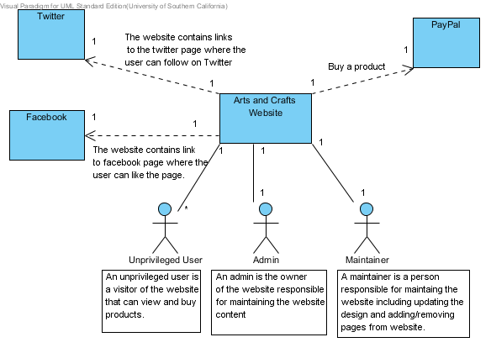
Figure 1: System Context Diagram

Table 1: Actors Summary
Actor | Description | Responsibilities
Unprivileged User | Any person who visits the website | - Purchase Product  - View Product Listings  - Write a Blog Comment
Administrator | The person who is owner of the site | - Add a blog entry  - Add/Remove/Update Products  - Add new pages  - Change website designs  - Track visitor for website
Maintainer | The person who maintains the website | - Add/Remove/Update Products  - Add new pages  - Change website designs

Artifacts & Information
The Artifacts and Information Diagram below shows different artifacts of the website. Charity and Product is the information displayed on the website. Customer contains the details of the customer i.e. name and email of the customers who have signed up for the newsletter. Blog contains the different Blog entries and Blog Comments. Customer can buy or view products and similarly, customers can also write Blog Comments.

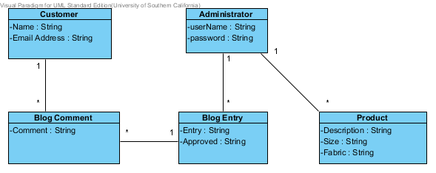
Figure 2: Artifacts and Information Diagram

Table 2: Artifacts and Information Summary
Artifact | Purpose
Customer | Helps the admin to send updates about the product to the people present in the newsletter list.
Product | Gives the visitor information about the product such as size, fabric, etc.
Administrator | The username and password of the administrator
Blog Comment | The blog comments written by the customer
Blog Entry | The blog entries added by the administrator

Behavior
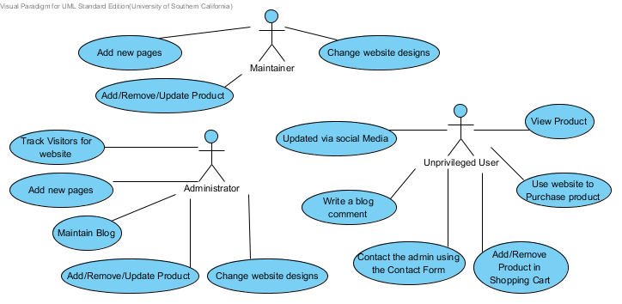
Figure 3: Process Diagram

View Product Listing
Table 3: Process Description (View Product Listing)
Identifier | UC-1 View Product Listing
Purpose | Allows the customer to view images of the all the products.
Requirements | WC_1551
Development Risks | None
Pre-conditions | The user must go to the Shop Page
Post-conditions | All the products images are displayed on the Shop page.
Table 4: Typical Course of Action (View Product Listing)
Seq# | Actor’s Action | System’s Response
1 | The user goes to the Shop page | The products images are displayed.

View Product Details
Table 5: Process Description (View Product Details)
Identifier | UC-2 View Product Details
Purpose | Allows the customer to view description of the product selected.
Requirements | WC_1280,WC_1282
Development Risks | None
Pre-conditions | The user must go to the Shop Page and click on the product image for which description needs to be viewed.
Post-conditions | The selected products images and description is displayed on the Shop Page.
Table 6: Typical Course of Action (View Product Details)
Seq# | Actor’s Action | System’s Response
1 | The user goes to the Shop page and click on Product image. | The product’s images and description is displayed.

Add Product to Shopping Cart
Table 7: Process Description (Add Product)
Identifier | UC-3 Add Product to Shopping Cart
Purpose | Allows the customer to add product in the Shopping Cart
Requirements | WC_1266
Development Risks | None
Pre-conditions | The user must go to the Shop page and click on the product image.
Post-conditions | The selected Product is added in the Shopping Cart
Table 8: Typical Course of Action (Add Product)
Seq# | Actor’s Action | System’s Response
1 | The user clicks on Product image on Shop Page | The product images and description along with Add to Cart button is displayed
2 | The user clicks on the Add to Cart button | The selected product is added to the Cart

Remove Product from Shopping Cart
Table 9: Process Description (Remove Product)
Identifier | UC-4 Remove Product from Shopping Cart
Purpose | Allows the customer to remove products from the Shopping Cart
Requirements | WC_1266
Development Risks | None
Pre-conditions | The user is on the Shop page and product selected to remove must already be added in the Shopping Cart.
Post-conditions | The selected Product is removed from the shopping cart.
Table 10: Typical Course of Action (Remove Product)
Seq# | Actor’s Action | System’s Response
1 | The user clicks on View Cart button on the Shop Page. | All the products are added in the shopping cart are listed
2 | Select the product to remove and click on remove button | The selected product is removed from the Cart.

Purchase Product
Table 11: Process Description (Purchase Product)
Identifier | UC-5 Purchase Product
Purpose | Allows the customer to purchase product.
Requirements | WC_1264
Development Risks | None
Pre-conditions | The user is on the Shop page and has at least one product in the shopping Cart.
Post-conditions | The user is directed to the Pay-pal service

Table 12: Typical Course of Action (Purchase Product)
Seq# | Actor’s Action | System’s Response
1 | The user clicks on Checkout Button | The user is shown a list of all the items in the shopping cart and a ‘Pay with PayPal’ Button
2 | The user clicks on the Pay with PayPal button | The user is directed to Payment Gateway.
Table 13: Exceptional Course of Action (Purchase Product)
Seq# | Actor’s Action | System’s Response
1 | The user clicks on Checkout Button | The user is shown a list of all the items in the shopping cart and a ‘Pay with PayPal’ Button
2 | The user clicks on the Pay with PayPal button | In case the PayPal service is down and a transaction cannot be made, an error message is displayed ‘Unable To Proceed, Try again Later.’

Write a Blog comment
Table 14: Process Description (Write a Blog Comment)
Identifier | UC-6 Write a Blog Comment
Purpose | Allows the customer to comment on a blog
Requirements | WC_1267
Development Risks | None
Pre-conditions | The user must click on the Blog Link. This link is present at the bottom of all pages.
Post-conditions | The comment written by the user is sent to admin to confirm.
Table 15: Typical Course of Action (Write a Blog Comment)
Seq# | Actor’s Action | System’s Response
1 | The user clicks on the Blogs Link. | The Blogs Page is displayed in a new window.
2 | The user enters name, email and comment and clicks on Post Comment | The comment is sent to admin for confirmation.

Give Feedback
Table 16: Process Description (Sign up for Updates)
Identifier | UC-7 Give Feedback
Purpose | Allows the customer to send email to the client to give feedback.
Requirements | WC_2271
Development Risks | None
Pre-conditions | The user is on the Contacts Page.
Post-conditions | An email is sent to the client with the feedback given.

Table 17: Typical Course of Action (Sign up for updates)
Seq# | Actor’s Action | System’s Response
1 | The user enter the name, email, subject and comments in the respective text boxes and clicks on Send | A success message is displayed at the bottom of the page and an email is sent to the client with the user’s name email and Comments.
Table 18: Alternate Course of Action (Sign up for updates)
Seq# | Actor’s Action | System’s Response
1 | The user enters the comments in the comment text boxes and clicks on Send | An error message is displayed at the bottom of the page that ‘  Please confirm the fields and submit it again.’  The mandatory fields that the left blank are highlighted in red.

Updated by Social Media
Table 19: Process Description (Social Media)
Identifier | UC-8 Updated by social media
Purpose | Allows the customer to go the Facebook and twitter pages
Requirements | WC_1276
Development Risks | None
Pre-conditions | The user must click on the Facebook or twitter link. These links are provided at the bottom of all pages
Post-conditions | The user is redirected to the Facebook or twitter page.
Table 20: Typical Course of Action (Social Media)
Seq# | Actor’s Action | System’s Response
1 | The user clicks on Facebook link at the bottom of the Page. | The website page on Facebook is liked by the user.
2 | The user clicks on the Twitter link at the bottom of the Page. | The user starts following the website on Twitter.

Table 21: Alternate Course of Action (Social Media)
Seq# | Actor’s Action | System’s Response
1 | The user clicks on Facebook link at the bottom of the Page. | The user is redirected to the Login page of Facebook
2 | The user clicks on the Twitter link at the bottom of the Page. | The user is redirected to Login page of Twitter.

Add a blog entry
Table 22: Process Description (Maintain Blog)
Identifier | UC-9 Add a blog entry
Purpose | Allows the admin to maintain a blog
Requirements | WC_1273
Development Risks | None
Pre-conditions | The admin is on the Blogs Page
Post-conditions | The entry written by the admin is added in the blog

Table 23: Typical Course of Action (Maintain Blog)
Seq# | Actor’s Action | System’s Response
1 | The admin adds a blog entry | An inbuilt plugin is used for blogs which filters the blog entry for any bad html tags and if correct, stores it in the database. The blog entry added is shown amongst the other blog entries already present in the system.

NDI/NCS Interoperability Analysis

Introduction
Our project is a single NDI project. All of our functionalities are provided by Wordpress. Wordpress is used for building website. The various requirements such as shopping cart, blog and product listings are provided by Wordpress modules. Since all of these modules are present in Wordpress itself, it is needless to discuss the interoperability of these components.

COTS / GOTS / ROTS / Open Source / NCS
Table 24: NDI Products Listing
NDI/NCS Products | Purposes
Wordpress | Platform to provide all functionality in website.

Connectors

We do not have any connectors because we have only one NCS

Legacy System
There is no current system.

System Structure

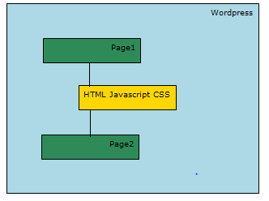

Evaluation Summary
Table 25: NDI Evaluation
NDI | Usages | Comments
Wordpress | Wordpress provides an open source blogging feature and shopping cart module along with the capability to modify the user interface. | Positive Points Ease of use Flexible in designing the user interface  Negative Points The website is difficult to maintain in Wordpress than Webs.

